**Create Scheduled Webjobs**

Ref: <https://nishantrana.me/2017/03/21/scheduling-a-web-job-console-application-using-azure-scheduler/>

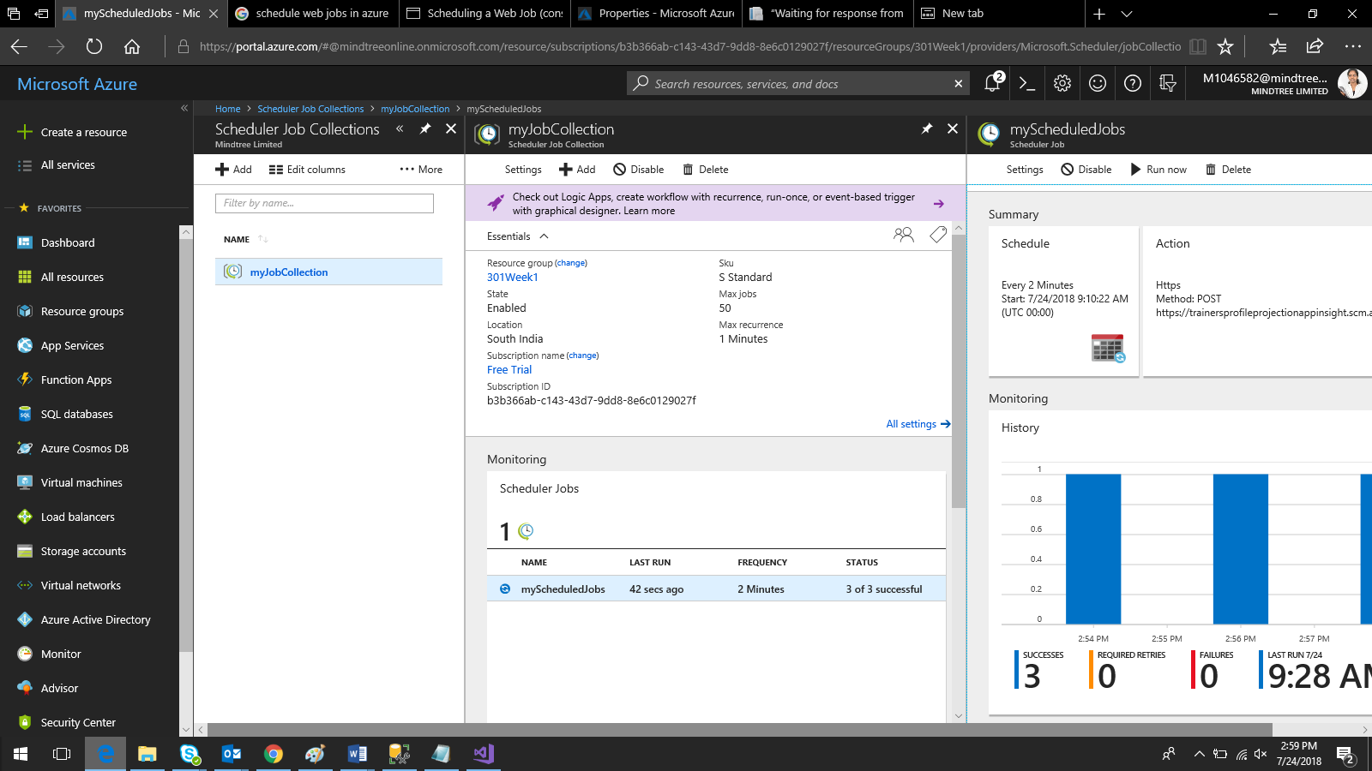

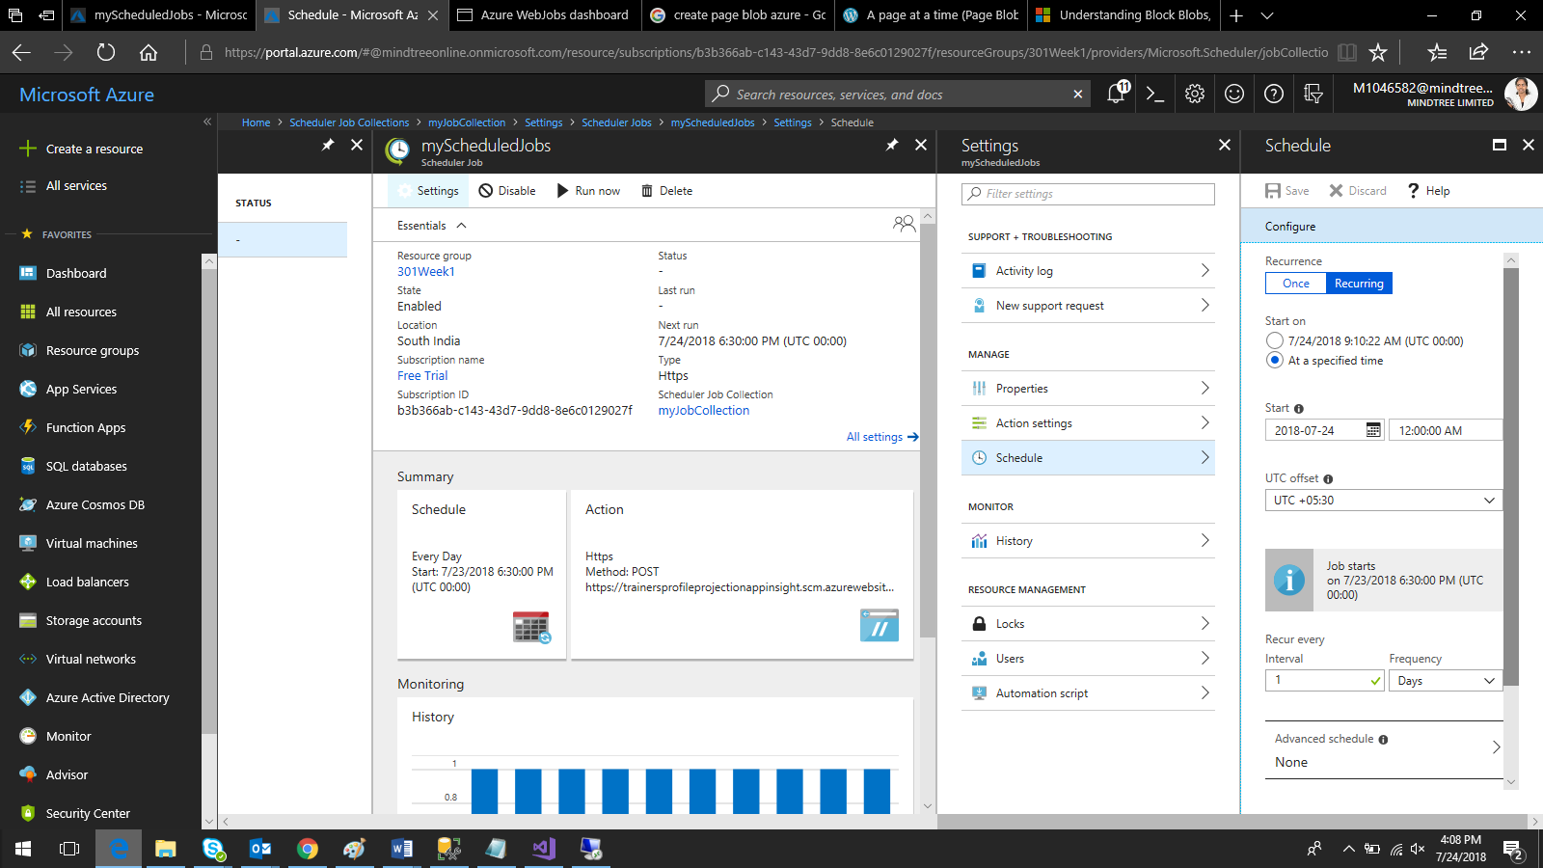

Log:-

